Privilege Information Utility In Pega

This is a component provided by Pega in order to help manually integrate new privileges into your existing roles.

Keeping in mind the new security privileges in keeping with Pega’s best practice guidance to have a strong security architecture. It helps in providing the information on the existing structure of access groups, privileges in your application.

What does this do?

Creates a report of the existing structure of access groups, roles, and privileges in your application.

Lets see how to do it in Pega

First download the component and import it then check in application definition whether branch is available or not and add it

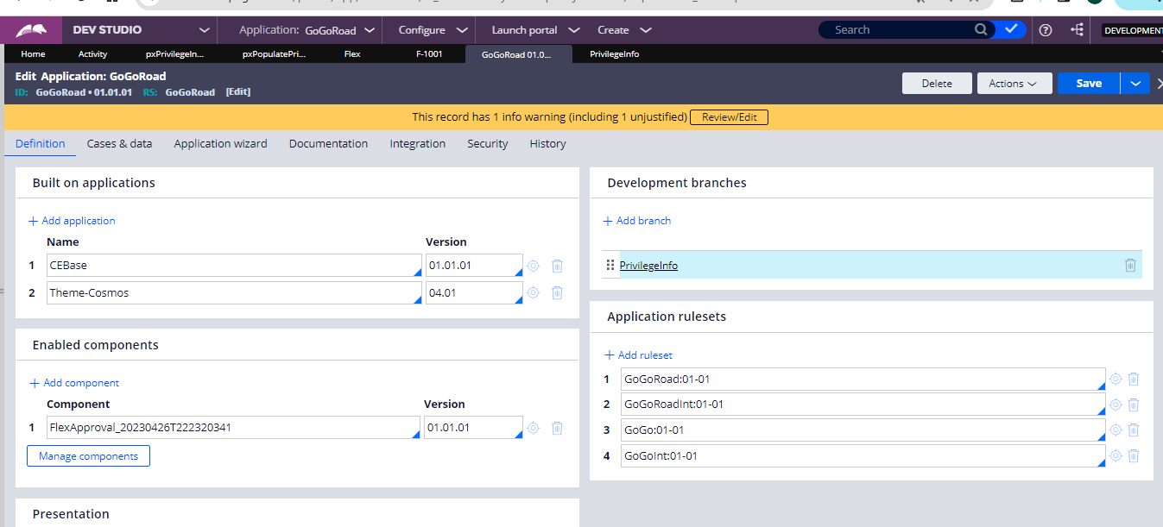

Now inside this branch we will be having the pxPrivilegeInformation Activity now if we run the activity and you will the excel export of access groups, role name, Privilege class, Privilege name

And after we run this activity we get export in an excel

So this is helpful to know which role has which privilege all at once we can know easily by using this component.